BOVINE DIGESTIVE SYSTEM -- Lectures 5-7

Objectives:

1. Identify the major disease conditions that affect the rumen of cattle. List etiologies and describe the pathogenesis of these conditions.

2. List the common and uncommon sequelae of traumatic gastritis in cattle.

3. Identify conditions which may be confused with vagus indigestion in cattle.

4. Explain the rationale for the treatment of fermentative indigestion in cattle.

5. Summarize the finding you would expect in a normal rumen fluid sample.

6. Describe the pathophysiology of acute rumen acidosis.

I. Traumatic reticuloperitonitis (traumatic gastritis, hardware disease)

A. Etiology -- foreign object penetration of the reticulum resulting in localized or generalized peritonitis

1. Syndrome depends upon several factors

a. Size, shape, and nature of the foreign body

b. Location and degree of damage at the puncture site

c. Degree of contamination at the time of puncture and subsequent to the puncture

2. Sequelae (see chart)

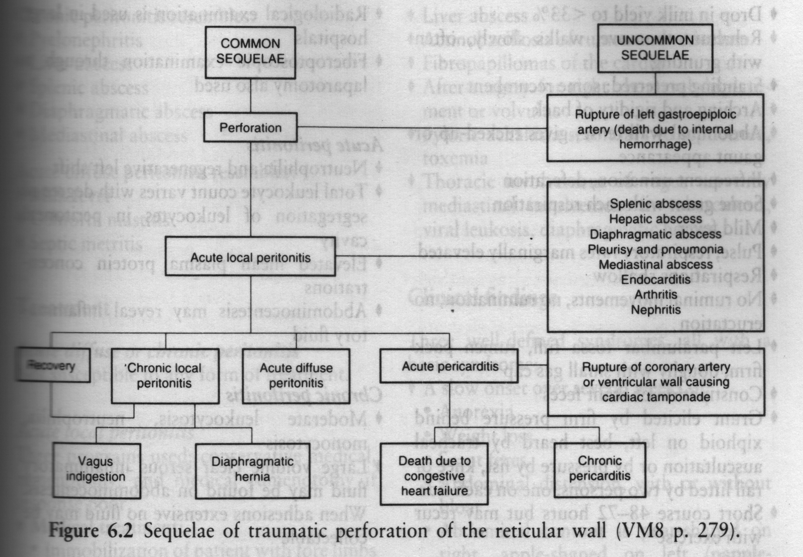

From Veterinary Medicine by Blood

B. Clinical signs

1. Fever, anorexia, depression, decreased or absent rumen contractions

2. Cranial abdominal pain, reluctance to move or lie down, trembling of triceps muscles

3. Expiratory grunt, arched back stance

4. Vomition sometimes observed

5. Other signs referable to type of penetration

a. Muffled heart sounds

b. Distended jugular veins associated with heart failure

6. Neutrophilic leukocytosis with a left shift

C. Differential diagnosis

1. Other causes of peritonitis

2. Other causes of heart failure

3. Systemic diseases accompanied by pain and/or sepsis

D. Treatment

1. Conservative, medical treatment

a. Magnet

b. Antibiotics

2. Surgery

II. Vagus indigestion

A. Definition

1. Characterized by gross distention of the rumen and sometimes bloat

2. Produced experimentally but may not occur naturally

B. Types

1. Experimental

a. Functional stenosis between the reticulum and the omasum with atony of the rumen and reticulum

b. Functional stenosis between the reticulum and omasum with normal or hyperactive rumenal and reticular motility

c. Permanent functional stenosis of the pylorus with atony or normal activity of the reticulum

d. Incomplete pyloric stenosis

2. Natural

a. Anterior functional stenosis (omasal transport failure)

1.) Most common type

2.) Ingesta fails to flow through into the abomasums

3.) Associated with pathology of the posterior thorax or anterior abdomen
4.) Ruminal hypermotility is more common than hypomotility

b. Posterior functional stenosis

1.) Produces distention of both the rumen and abomasums

2.) Characterized by relux of ingesta into the rumen

3.) Sequestration of chloride is a common problem and can be identified by serum determination

4.) May also be a sequel to disease which affects the blood supply to the muscular wall of the abomasums

C. Clinical signs

1. Gradual onset, gradual abdominal distention, decreased fecal output

2. Typical abdominal appearance

3. Hypochloremia (differentiate anterior from posterior)

D. Differential diagnosis

1. True intraluminal obstruction

2. Diaphragmatic herniation

3. Advanced pregnancy or hydrops of the uterus

E. Therapy

1. Surgery -- usually exploratory laparo-rumenotomy or other specific corrective procedure

2. Overall recovery rate is about 30% for vagal indigestion type problems

III. Indigestion associated with fermentative disorders

A. Fermentative problems may end up causing motor dysfunction

1. Arise from food abnormalities

2. Ration adjustments are part of the solution

B. Motility disturbances may result in decreased microbial activity but are primarily attributable to changes in ruminal fluid or from feed changes; they result from lesions that disrupt neuromuscular impulses

C. Normal rumen fluid -- a continuous culture system

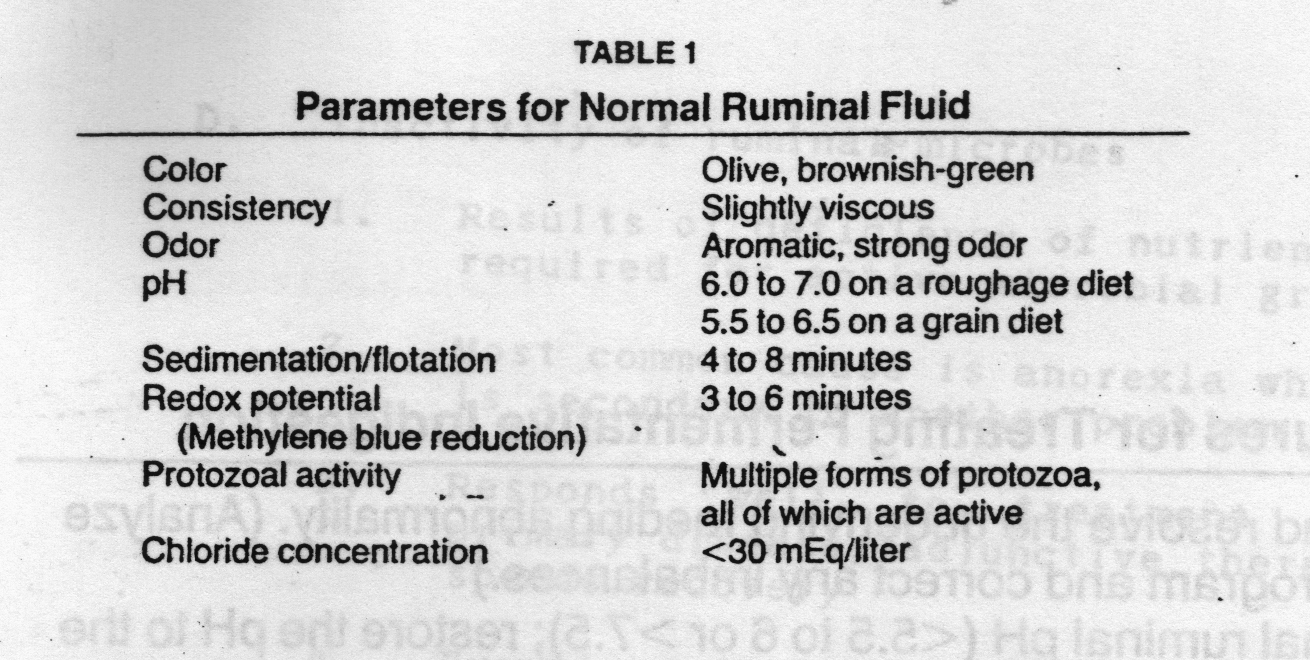

1. Animal control factors

a. Salivation

b. Mixing and rumination

c. Ingesta outflow

d. Eructation

2. Diet control factors

a. Quality

b. Quantity

c. Rate of delivery

d. Balance of elements

e. Solubility

f. Particle size

g. Toxic substances

3. Microbes

a. Bacteria -- mostly anaerobes

b. Protozoa

1.) Role unclear -- fermentation can proceed without them

2.) Can reflect changes within the environment of the rumen

4. Feed characteristics influence fermentation

a. Excesses or deficiencies of feed substrates produce an imbalance in the composition of the microbial population

b. Abnormalities in fermentation can ensue when potentially acceptable feeds are introduced too abruptly, or when cattle are fed feeds with excesses or deficiencies of specific nutrients for too long a period of time

c. An overgrowth of ruminal microbes that degrade excessive amounts of some dietary constituents can lead to the production of fermentation end products that impair ruminal function

d. An insufficient supply of nutrients reduces microbial activities, and in extreme cases reduces the digestibility of feedstuffs

D. Inactivity of rumen microbes

1. Results of deficiency of nutrients required for active microbial growth

2. Most common cause is anorexia which is secondary to another problem

3. Responds well to treatment of the primary disease; adjunctive therapy speeds recovery

4. Examples of this type of problem include "hay belly" and rumen impaction

E. Simple indigestion

1. Sequel to an abrupt change in the animal's diet

2. Usually mild and self-limiting

3. Ruminal motor activity is reduced but not absent

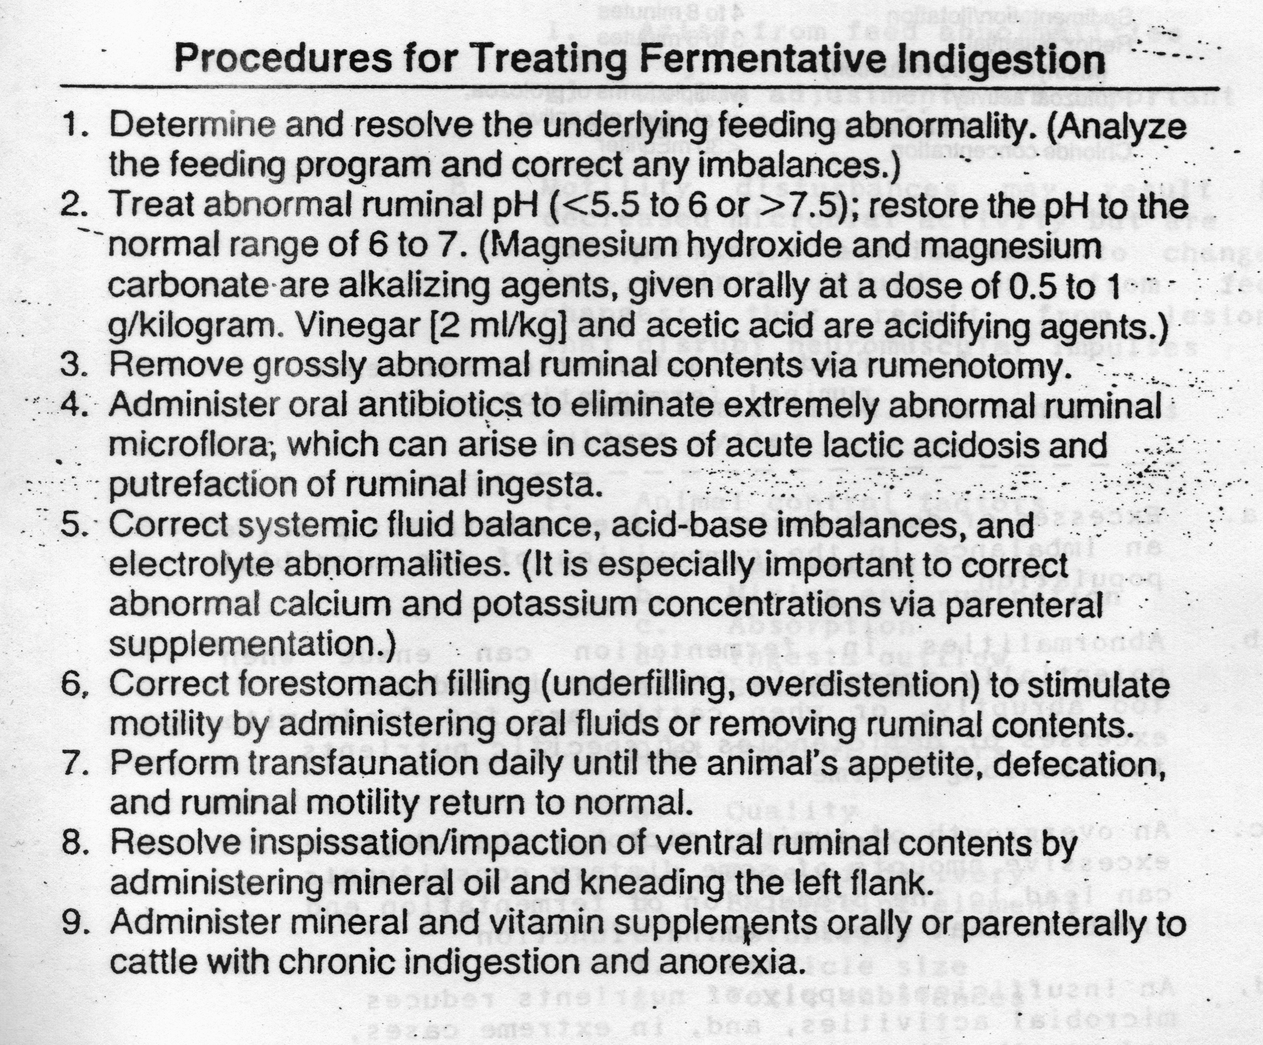

F. Acute ruminal acidosis -- most severe form of fermentative indigestion

1. Cause -- rapid intra-ruminal fermentation associated with excess amounts of carbohydrates; lack of acclimation to the substrate

2. Occurrence

a. Feeder cattle

1.) Starting cattle on feed

2.) Sudden change in the ration, usually roughage to grain

3.) Sudden increases in feed amounts

4.) Weather changes

b. Dairy cattle

1.) Sudden increase in grain feeding

2.) Sudden alterations of the ration

3. Pathophysiology

a. Rapid decrease in ruminal pH

b. Decline in rumen protozoa
c. Increase in Gram-positive organisms -- Streptococcus and
Lactobacillus

d. Increase in rumen lactic acid

e. Rumen osmotic pressure increases, leading to hypovolemia

f. As pH goes below 5, Streptococcus dies off but Lactobacillus increases

g. Chemical irritation of the rumen occurs

h. Histamines increase, endotoxins increase

i. Diarrhea develops, systemic effects are severe

4. Signs

a. Complete anorexia

b. Marked depression

c. Rumen atony

d. Dehydration

e. Abdominal distention

f. Diarrhea

g. Coma

5. Consequences

a. Death may be sudden without animals developing diarrhea

b. Mycotic rumenitis

c. Polioencephalomalacia

d. Laminitis

6. Diagnosis

a. History -- occurs 12-18 hours after diet change

b. Physical findings

c. Very low rumen pH

d. Hemoconcentration, low blood pH

e. Increased blood lactates and pyruvates

7. Treatment

a. Control of rumen acid

1.) Alkalinizing agents

2.) Antibiotics

3.) Rumen lavage

4.) Rumenostomy

b. Correction of dehydration

c. Symptomatic therapy

1.) Antihistamines

2.) Antibiotics

3.) Antiinflammatory drugs

4.) Rumen transfaunation

5.) Thiamine

8. Prevention

a. Ration adaptation

b. Feed additives such as sodium bicarbonate, ionophores, probiotics

G. Chronic rumen acidosis

1. Results from feeding high proportions of (finely ground) concentrates at the expense of appropriate quantities of long stemmed or adequate particle size roughages

2. Similar to the acute form except that the condition develops over a loinger period of time
3. Insidious onset of symptoms

4. Other conditions may be more apparent

a. Low milk butterfat test

b. Chronic laminitis

c. Chronic indigestion

5. Alter the ration to include more fiber and roughage with adequate particle size and buffer the ration with sodium bicarbonate

IV. Enterotoxemia (overeating disease)

A. Etiology

1. Acute infectious but not contagious disease characterized by sudden death in feedlot cattle

2. Clostridium perfringens type A, C or D

a. Type A may be associated with gastrointestinal hemorrhage in cattle

1.) Risk factors

a.) High production

b.) < 100 days in milk

c.) Aggressive eating

d.) Second lactation or greater cows

e.) Recent feed changes

f.) Feeding TMR and selection for smaller particle size or decreased long stemmed fiber

g.) Rumen acidosis

h.) Excessive rumen fill with spillover into the intestine of contents with high soluble protein and carbohydrate levels

i.) Feeding corn silage ensiled < one week

j.) Decreased intestinal motility

2.) Clinical signs

a.) Acute onset

b.) Anorexia

c.) No milk

d.) Painful and distended abdomen

e.) Intestinal hemorrhage

3.) Prognosis -- guarded to poor

b. Type C produces hemorrhagic enteritis in calves

1.) Necrotic enteritis in newborn calves

2.) Diarrhea may not even develop

3.) Risk factors

a.) Ingestion of the organism with colostrum

b.) Ingestion of protein rich diet in a protease-deficient intestinal tract may allow rapid growth of the organism

c.) Protein rich milk replacer/high grain consumption

d.) Inconsistent feeding practices

e.) Limited access to water after feed consumption

f.) Abnormal intestinal flora from abundant oral medication

g.) Stressful interventions that result in erratic intake

c. Type D produces mucoid and catarrhal enteritis in feedlot cattle

1.) Morbidity is 5-10%

2.) Mortality is near 100%

3.) Convulsions

4.) Paralysis of posterior limbs

5.) Colic signs

3. Diagnosis

a. History

b. Clinical signs

c. Lesions

d. Laboratory samples to submit

1.) Intestinal contents

2.) Blood clots

3.) Intestinal lining placed in formalin

4.) Liver

5.) Blood or serum

6.) Feces

4. Prevention

a. Management to gradually get cattle on feed

b. Avoid overfilling on concentrates

c. Rumen buffers

d. Antibiotics in the feed

e. Vaccination available for types A, C and D

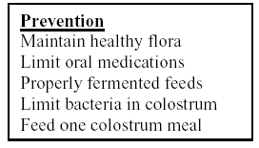

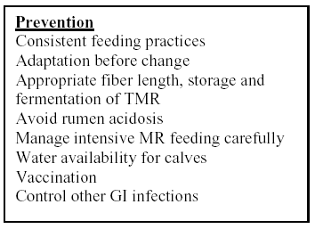

From : McGuirk, Managing Clostridial Diseases in Cattle

V. Peritonitis

A. Causes -- differential diagnosis includes many common bovine diseases

1. Foreign body penetration of the stomach

2. Perforations of the reproductive tract

3. Ulcers

4. Umbilical infections

5. Complications of surgery or other procedures such as intraperitoneal injections or trocharization of the rumen

B. Clinical signs

1. Related to the extent of the sepsis

2. Arched back, bruxism, expiratory grunt

3. Shock, fever, pain

4. Bloated appearance and/or "pings" related to gastrointestinal stasis

5. Rectal examination may reveal adhesions or "stovepipe rectum"

C. Diagnosis

1. Clinical signs

2. Clinical pathology

3. Exploratory laparotomy

4. Treatment -- symptomatic

