BOVINE DIGESTIVE SYSTEM -- Lecture 11

Objectives

1. List and discuss the factors involved in neonatal diarrhea complex in calves.

2. Describe the pathogenesis of neonatal diarrhea in calves.

3. Outline a method for control and prevention of neonatal diarrhea in a beef or dairy herd.

Neonatal Diarrhea Complex

I. Introduction -- Diarrhea is a clinical sign of disease which can have many causes. The primary physiological result is the failure to absorb fluids or increased secretion of fluids or a combination. While an infectious agent may be a primary cause of damage, death in most cases is due to fluid and electrolyte losses.

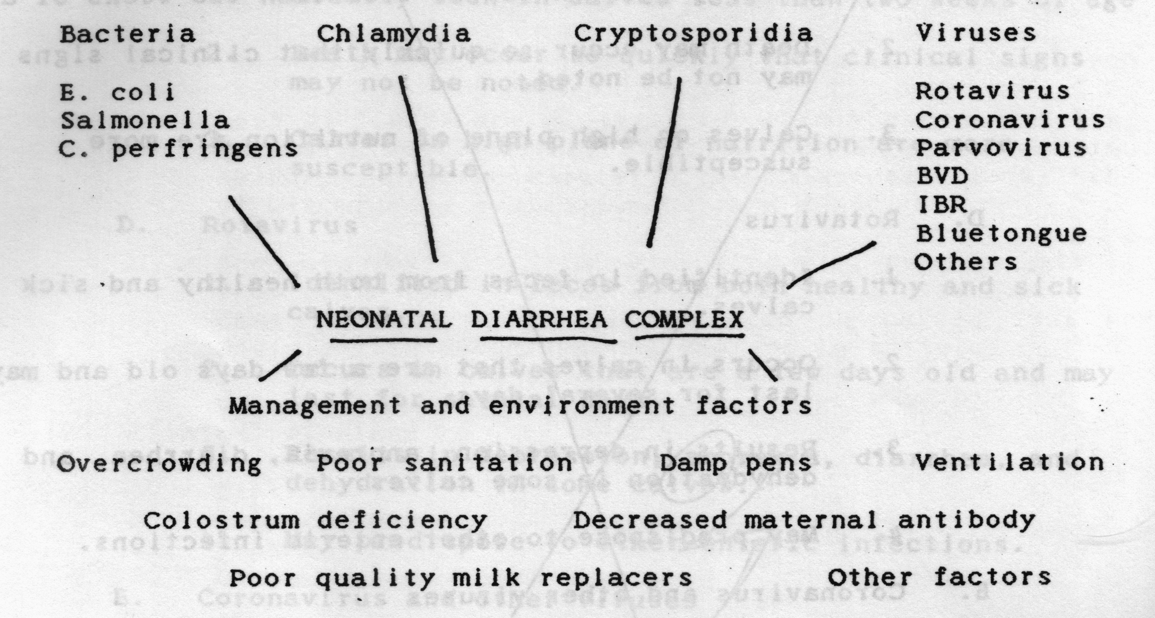

II. Etiology

A. E. coli

1. E. coli causes diarrhea in caves as a result of septicemic or enteric infection

2. Septicemic invasion can cause shock with a low grade diarrhea in very young calves mostly under four days of age. Typical diarrhea signs. Acute death.

3. Enterotoxigenic E. coli produces a severe watery diarrhea. Enterotoxin stimulates secretion of water, electrolytes. Weakness may develop before the diarrhea does.
B. Salmonellosis

1. Calves are usually 1-2 weeks of age before clinical signs develop.

2. Disease may be peracute with fever and death.

3. Acute form may have profuse watery diarrhea with blood. Dehydration is usually severe.

4. Salmonella may be brought to a farm with purchased animals. Contaminated feed or water may be sources.

C. Clostridium perfringens types B and C enterotoxemia

1. Usually seen in calves less than two weeks of age

2. Death may occur so quickly that clinical signs may not be noted

3. Calves on a high plane of nutrition are more susceptible.

D. Rotavirus

1. Identified in feces from both healthy and sick calves

2. Occurs in calves that are a few days old and may last for several days

3. Clinical signs of depression, anorexia, diarrhea, and dehydration.

4. May predispose to other infections.

E. Coronavirus and other viruses

F. Coccidiosis

1. Usually seen in calves three weeks of age or older

2. 1000 oocysts can result in destruction of 24 billion intestinal cells

G. Cryptosporidiosis

1. Usually detected at 10-12 days of age

2. Zoonotic

III. Epidemiology

A Calves must ingest colostrum in adequate amounts as soon after birth as possible. Colostrum from heifers may not have as much globulin as that from older cows.

B. Weak calves may not be able to nurse properly.

C. Dairy calves fed on milk substitutes are more prone to get diarrhea than those fed on whole cow’s milk.

D. Housing and hygiene are very important factors as well in the development of colibacillosis and other enteric diseases.
E. Primary source of infection is feces of infected animals.

IV. Pathogenesis

A. Enterotoxins -- hypersecretion by crypt epithelium

B. Villous atrophy -- viral damage leads to malabsorption

C. Loss of fluids and electrolytes into the lumen of the intestine results in electrolyte imbalance, dehydration, acidosis, hyperkalemia (with severe acidosis), failure of the circulatory system, shock, and death.

D. Adequate levels of immunoglobulins will protect calves from death due to diarrhea but not necessarily from diarrhea. Case fatality rate in calves that are deficient in serum immunoglobulins will be high in spite of intensive antimicrobial therapy.

V. Clinical findings

A. Diarrhea

B. Dehydration

C. Weakness

D. Death

VI. Diagnosis

A. With single animals -- submit feces for examination

B. With herd outbreak -- submit affected animal for exam

VII. Therapy

A. Isolation of the affected animal

B. Alteration of the diet

1. Withhold milk for at least 24 hours

2. Use oral glucose and electrolyte replacement solutions for therapy

3. Or alternate between oral fluids and milk; but do not give at the same time

C. Fluid and electrolyte replacement

1. Oral route may be sufficient

2. Intravenous route necessary for severe shock or dehydration

D. Antibiotic therapy
1. Oral preparations ar of questionable value in severe cases

2. Systemic therapy is best in severe cases

E. Other therapy

1. Plasma, immunoglobulins

2. Atropine?

3. Aspirin, flunixin meglumine

4. Bismuth, kaopectate

F. Conclusions

1. Sick calves need lots of tender loving care

2. Timing

3. Fluids

VIII. Prevention and control

A. Reduce the degree of exposure of newborn animals to infectious agents

B. Provide maximum nonspecific resistence with adequate colostrum and optimum animal husbandry

C. Increase the specific resistance of the newborn by vaccination of the dam or the newborn

