BOVINE MEDICINE Metabolic Disease
Metabolic Disease, Body Condition Scoring, Fatty Liver, Ketosis, Pregnancy Toxemia

Objectives:
1. Define the body condition concept as applied to dairy cattle and describe the scale.
2. Identify and describe the lactation curve and energy requirements of a typical dairy cow and the relationship between body condition score, milk production, dry matter intake, and pregnancy.
3. Describe fatty liver syndrome and identify the factors involved in the pathogenesis of the problem.
4. Define ketosis, describe methods of diagnosis, and explain the rationale for therapy.
5. Compare and contrast ketosis and pregnancy toxemia.

Metabolic Diseases
I. Body condition scoring
A. Useful techniques of body condition scoring have been developed for most species.
B. Body condition, health, and nutrition are closely intertwined, especially in productive dairy cattle.
C. Dairy cows are given an objective score on a 1-5 basis with 1 being thin and 5 being obese.
D. This procedure can be carried out during other routine procedures such as reproductive examination.
E. Overly fat dry cows will have many more problems at calving time.
F. Refer to the Body Condition Scoring Guide.

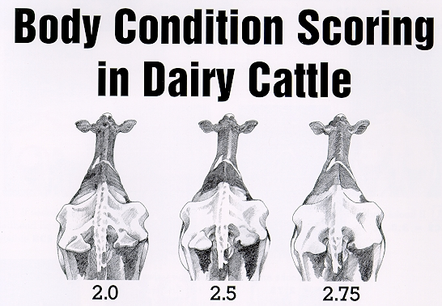

Begin by a review of the general names for the various body locations which will be referred to in the systematic approach to body condition scoring. Keep in mind that this system is designed to be done from behind the animal. Also you may have to discard you old system of BCS as the scores will probably be different. However, once this approach is accepted, it will allow repeatable BCS even when several different people do the scoring.
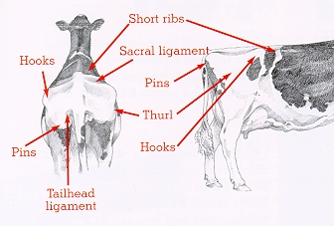

Make a decision about the line over the thurl, this is the cut point between 3.0 or less and 3.25 or greater scores.
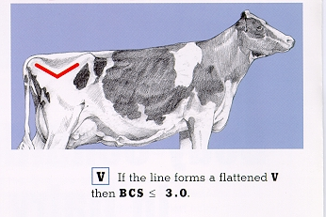

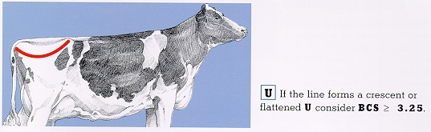
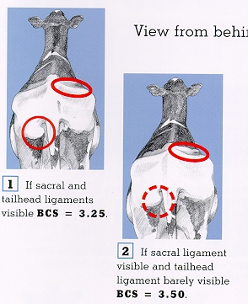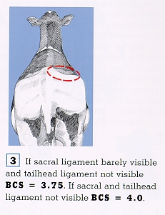
Then view from behind.

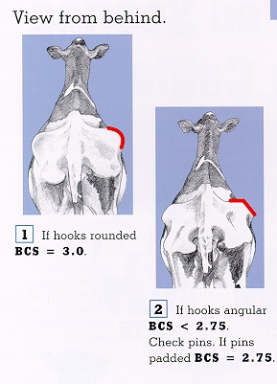
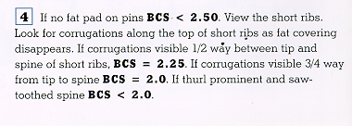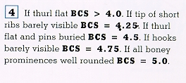
This system of body condition scoring in dairy cattle was developed with the support of Elanco Animal Health and taken from their bulletin AI 8478 (Rev. 9/96).

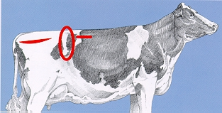

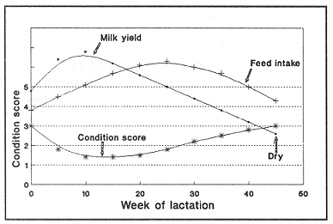
Relationship between body condition score, milk production, and dry matter intake.

II. Fatty liver syndrome
A. Peak incidence from 2 weeks prepartum to 10 weeks postpartum.
B. Individual cows with fatty liver syndrome are obese prior to illness and may have had a long dry period with access to quantities of high energy feed exceeding requirements.
C. Obese cows are predisposed to fatty liver syndrome by any condition that interferes with normal appetite in early postpartum period.
D. Although the liver can become fatty while the cow is gaining weight, most cases of fatty liver are associated with weight loss.
E. Fatty liver infiltration impairs liver function, increases disease susceptibility, may reduce fertility, and may lead to death.
F. Once fat is deposited in the liver, fat levels are not reduced until the cow reaches a state of positive energy balance, which may not occur until 8 to 12 weeks postpartum.
G. Clinical signs include high incidence of post partum disease often accompanied by leucopenia with degenerative left shift and elevation of liver enzymes.

H. Therapy—nearly the same as for ketosis, but often ineffective
1. 50% glucose intravenously; or 25% glucose/25% fructose
2. Protamine zinc insulin and glucose
3. Choline and niacin
4. Propylene glycol or sodium propionate
5. Antibiotics

III. Ketosis (acetonemia)
A. Definition
1. Characterized by an abnormally high concentration of ketone bodies in the body and body fluids.
2. Primary ketosis—negative energy balance, especially in early lactation.
3. Secondary ketosis—related to anorexia associated with another disease process.
B. Clinical signs
1. Decreased appetite and milk production
2. Some degree of hypocalcemia may accompany
3. Nervous form may occur occasionally
4. Odor of ketones on breath, in urine, and in milk
C. Diagnosis
1. Clinical signs
2. Tests for ketones in urine and milk
D. Therapy
1. Stimulate gluconeogenesis
2. Increase utilization of blood glucose
3. Reduce plasma ketones and free fatty acids
4. Supplement the ration

E. Prevention
1. Maintain proper body condition from the dry period through calving
2. Encourage maximum dry matter intake
3. Feed a balanced ration with high quality forages to early lactation cows
4. Minimize negative energy balance after calving
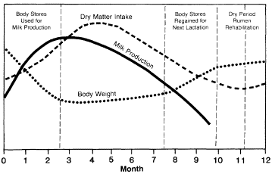

III. Preganacy toxemia
A. Occurs more frequently in beef cows and small ruminants
B. Similar to ketosis in may ways
C. Caused by chronic underfeeding during the pregnancy, usually lots of poor quality forage with no supplemental grain or energy

