BOVINE MUSCULOSKELETAL PROBLEMS

Objectives:

1. Distinguish the types of conditions which may affect the musculoskeletal system of cattle.

2. Compare and contrast the types of septic arthritis that may affect cattle

3. Relate the factors which may predispose to lameness in cattle to the conditions which affect the animals.

4. Explain and contrast the types of therapy used in combating lameness in cattle

5. Outline and describe the common diseases that affect the hoof of cattle.

6. Explain the lameness scoring system used in cattle lameness evaluation.

7. Compare the conditions that are associated with upper leg lameness in cattle.

8. Recommend management factors to help limit the incidence and severity of lameness in cattle.

9. Identify the common etiologies of muscle problems that affect cattle.

I. Septic arthritis

A. Types

1. Primary – infection introduced directly into the joint

2. Secondary – extension of infection from adjacent tissues

3. Tertiary – infection as a result of septicemia

B. Progression of the disease

1. Bacterial invasion

2. Cellular response

3. Synovitis

4. Cartilage destruction

C. Clinical signs

1. Lameness, progressive to non-weight bearing

2. Cardinal signs of inflammation

D. Clinical diagnosis

1. Physical examination

2. Paracentesis of the joint

3. Analysis of the fluid; cell count, staining

4. Aerobic and/or anaerobic culture and sensitivity

5. Radiology and/or ultrasound

E. Therapy

1. Antibiotics

2. Joint drainage or lavage

II. Degenerative joint disease

A. Definition – progressive deterioration of articular cartilage with variable degrees
of periarticular osseous remodeling

B. Cause – often related to direct trauma and influenced by abnormal weight bearing or poor conformation

C. Clinical signs

1. Age related – often seen in older animals

2. Onset may be insidious or follow an acute injury

3. Condition is usually progressive and leads to decreased performance or inability to function

4. Affected joints have effusion and pain

5. Larger weight bearing joints are most often affected

D. Diagnosis

1. Physical examination

2. Clinical signs

3. Radiology

E. Therapy – palliative

III. Oseochondrosis

A. Developmental disease characterized by a defect of endochondral ossification

B. Cause – vague, dietary, conformation, hereditary

C. Clinical signs

1. Most often seen in younger animals

2. Osseous enlargements at the physeal plates

3. Usually involves more than one limb

4. May involve mild, progressive lameness

D. Diagnosis

1. History and clinical signs

2. Radiological findings
E. Therapy – dietary manipulation

IV. Rickets

A. Lack of mineralization of rapidly growing bones

B. Commonly associated with a deficiency of phosphorus or vitamin D

C. Clinical signs

1. Stiffness, reluctance to move, lameness

2. Curvature of long bones

3. Partial anorexia, decreased growth and weight gains, poor feed efficiency

V. Review of lameness in cattle

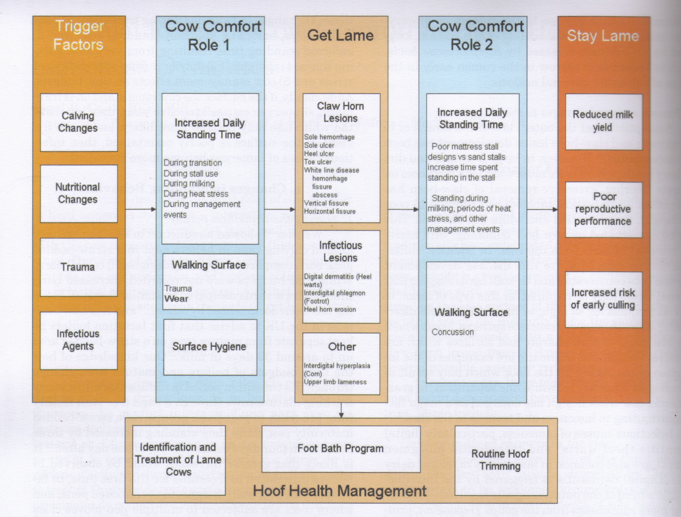

A. Factors involved in cattle lameness

1. Heredity, conformation

2. Nutrition

a. Energy, fiber, acidosis

b. Trace minerals

c. Vitamins

3. Environment

4. Animal behaviors, stress
B. Normal gait in cattle

C. Degrees of lameness, lameness scoring

1. Locomotion score 1 – normal

stands and walks normally; all feet placed with purpose

2. Locomotion score 2 – mildly lame

stands with a flat back, but arches when walks; gait is slightly abnormal

3. Locomotion score 3 – moderately lame

stands and walks with an arched back; short strides with one or more legs

4. Locomotion score 4 – lame

arched back standing and walking; one or more limbs favored but at least partially weight bearing

5. Locomotion score 5 – severely lame

arched back, refuses to bear weight on one limb; may refuse or have great difficulty moving from lying position

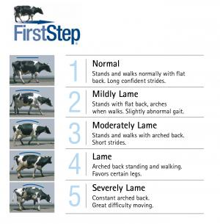

VI. Foot problems

A. Overgrown hooves

1. Etiology

a. Lack of wear due to interaction with too soft of a surface

b. Response to contact with overly hard surfaces (concrete)

c. Congenital problems

1.) Scissor claws

2.) Corkscrew claws

3.) Wall cracks

2. Diagnosis – physical examination and history

3. Therapy – corrective hoof trimming

4. Prevention

B. Foot rot (Interdigital necrobacillosis) (Foul in the foot)
Note: laymen refer to almost any foot problem as foot rot

1. Cause – Fusobacterium (sometimes Bacteriodes)

2. Clinical signs

a. Sudden onset of lameness, usually one limb

b. Swollen interdigital space and often some swelling above the foot

c. Foul odor in the interdigital space

3. Diagnosis – usually made by observing the clinical signs together with history

4. Therapy

a. Procaine penicillin G

b. Oxytetracycline

5. Prevention and control

a. Vaccination

b. Foot baths—copper sulfate, formalin, zinc sulfate

c. Environmental control

C. Verrucose dermatitis (Heel wart)

1. Probably the number one cause of lameness in dairy cattle in North America

2. Clinically a chronic, proliferative growth of the skin above the heel, often of the hind feet

3. Cause – Treponema – infectious, contagious

4. Aggravated by wet, dirty environmental conditions

5. Therapy

a. Surgery

b. Cryotherapy

c. Oxytetracycline injection

6. Control and prevention

a. Clean environment

b. Daily spray of the heels with oxytetracycline

c. Vaccination

D. Trauma

1. Bruises

2. Hoof cracks

3. Sole ulceration

a. Toe ulcers

b. Rusterholz ulcer (typical sole ulcer)

E. Laminitis

1. Acute

a. Often associated with an acute disease such as metritis, retained fetal membranes, mastitis, pneumonia, rumenitis, or other serious disease condition

b. Clinical signs may be masked by the associated disease

1.) Stiffness, pain, reluctance to walk

2.) Swelling and tenderness above the coronet and over the bulbs of the heel

3.) Veins in the lower leg may be distended

c. Treatment -- symptomatic

2. Chronic

a. Often associated with chronic rumen acidosis

b. Hooves often grow wide and flat

c. Hemorrhages occur within the hoof in the laminar area and may subsequently become infected resulting in white line disease

d. Therapy

1.) Hoof trimming

2.) Palliative treatment

F. Interdigital hyperplasia (Corn, Interdigital Fibroma)

1. Description – thickening of the interdigital skin

2. Often associated with an accumulation of fat and repeated trauma of the area (spreading of toes when walking)

3. Observed more often in heavy beef cattle

4. Therapy – surgery

G. Fracture of the coffin bone

H. Septic pedal arthritis (or osteoarthritis)

1. Usually a sequel to an extension of another problem or condition

2. Swelling at the coronary band is a good indication of the condition together with non-weight bearing lameness

3. Therapy – surgery

VII. Upper limb lameness

A. Arthrogryposis, ankylosis

B. Contracted tendons

C. Spondylitis

D. Sprains, subluxations, luxations

E. Hip dysplasia

F. Other miscellaneous conditions

VIII. Muscle conditions

A. Nutritional myodegeneration (White muscle disease)

1. Etiology – acute myodegenerative disease of the skeletal or cardiac muscle; related to a deficiency of vitamin E and/or selenium

2. Clinical signs

a. Cardiac form – less common in cattle

1.) Sudden onset

2.) Sudden death

b. Skeletal form

1.) Slower onset of clinical signs

2.) Muscle weakness, stiffness, trembling

3.) Elevation of muscle enzymes

3. Treatment and prevention with injectable products containing vitamin E and selenium; oral products with sustained release have been withdrawn from the market; feed supplementation

B. Sarcocystis

C. Clostridial mysositis (Blackleg, Malignant edema)

1. Etiology – Clostridial organisms

2. Affects cattle primarily 6 months to two years of age

3. Usually occurs during hot weather

4. Characterized by sudden death with gas under the skin

5. Treatment – seldom effective as the animal is usually severely ill

6. Prevention – very effective using vaccination with bacterins

